Context: Smart Data-Informed Blended Learning.

Blended Learning Scenario
Describe the blended experience addressed in your study by using 150 words. Please include your definition of blended learning concerning the experience designed and implemented at your institutions, details of its instructional design, and some information about the context of its deployment.
Combination of Physical and Digital Components
Use a figure to describe how students interact with physical and digital components throughout the blended learning experience. By physical components, we mean residential classroom activities (often face-to-face); and by digital components, we mean small private online courses (SPOC), or massive open online courses (MOOC), or other online content. For example, the interactions could be (among many possible configurations):
- Sequential. Students interact with digital and the physical components consecutively throughout the course, with no overlapping between them.

- Parallel. Students interact with digital and physical components in parallel by means of separate mechanisms.

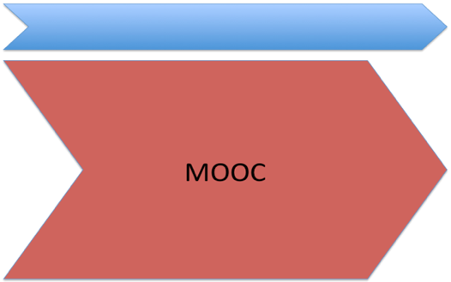
- Interleaved. Students interact with both digital and physical components ate the same time, and these two types of components are highly integrated.

Context: Smart Data-Informed Blended Learning.
Expected Results
In the following lines, please described the results you expected from the implementation of the blended learning experience concerning instructional technology adoption, learning outcomes, and/or students and teaching perceptions.
- Expected result 1
- Expected result 2
- Expected result 3
Metrics Used for Assessing the Results of the Blended Learning Experience
Success metrics:
List metrics obtained to evaluate the success of the experience from a learning perspective. For example:
- Pre/Post Learning gains
- Course grades
- Course attrition rate
- Student teaching evaluation
- Scores according to rubrics
Classroom metrics:
List metrics obtained direct or indirect assessment during face-to-face activities. For example:
- Student motivation.
- Student participation in classroom activities.
- Student time investment.
- Student satisfaction with course components.

Online metrics:
List metrics obtained from student interaction with online content. For example:
- Student performance in online assessment.
- Student interaction with online content.
- Time on task (i.e. time spent watching videos).
- Forum activity (i.e. students’ posts)
- Number of online assessments completed.
- Peer evaluations conducted in the online environment.

Challenge: Complete only if there was a challenge or barrier you face to measure the metric(s) above.
Challenge: Complete only if there was a challenge or barrier you face to measure the metric(s) above. For example, time availability for data collection.
Challenge: Complete only if there was a challenge or barrier you face to measure the metric(s) above. For example, faculty workload.
Lessons learned
Share a second lesson learned from assessing a blended experience.
Share a second lesson learned from assessing a blended experience.
Share a lesson learned from assessing the blended experience presented in your study, considering its success or promising practices that did not turn out as expected.

